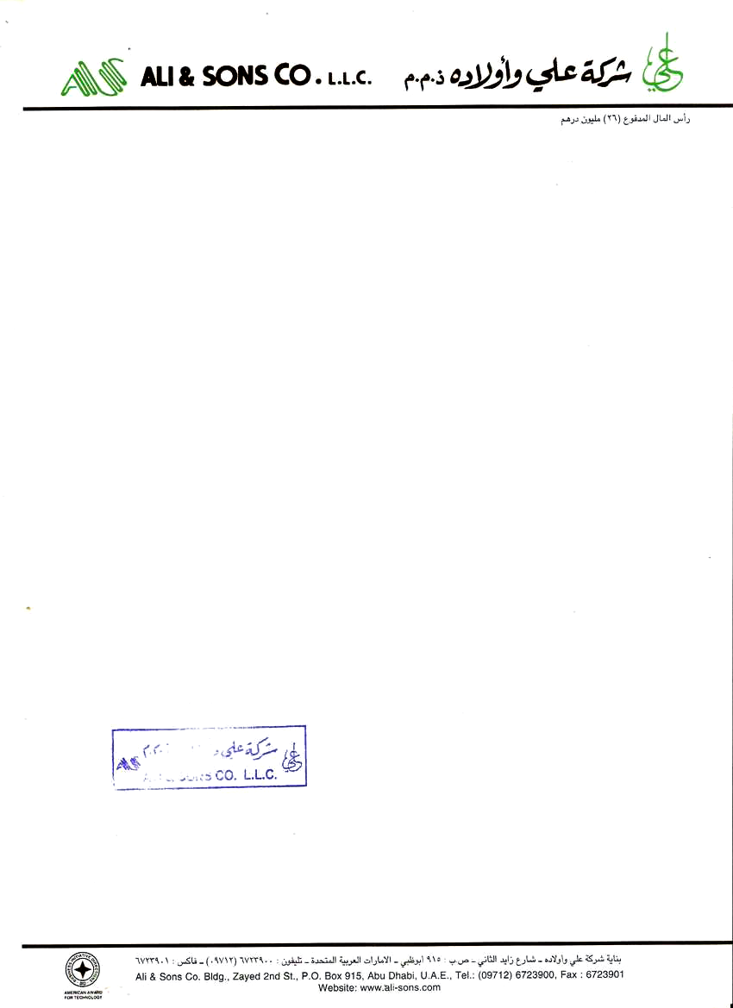

Ref: AS/ADM/L1808/09

Date: <To>

**TO WHOM IT MAY CONCERN**

Subject : EMPLOYMENT CERTIFICATE

This is to certify that MR. <name>, Pakistani National and holder of Passport No. <Passport>, worked in our Company as an "<Designation>" from <From> up to <To>.

This certificate is issued upon the request of Mr. <Name>. Please note, however, the Company will not accept any legal or financial responsibility in UAE on his behalf.

For ALI&SONS CO.

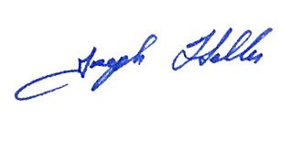

JOSEPH KOURIEH

Admin & HR Director